**Project Design Phase-I**

**Solution Architecture**

|  |  |
| --- | --- |
| Date | 11 October 2022 |
| Team ID | PNT2022TMID12996 |
| Project Name | Project – PLASMA DONOR APPLICATION |
| Maximum Marks | 4 Marks |

**Solution Architecture:**

Solution architecture is a complex process – with many sub-processes – that bridges the gap between business problems and technology solutions. Its goals are to:

Modules used: HTML, Javascript, Python-Flask, Kubernetes, Docker, SendGrid

IBM Technologies used:

* IBM Cloud
* IBM Cloud Object Storage
* IBM DB2
* IBM Container Registry

**Solution Architecture Diagram:**

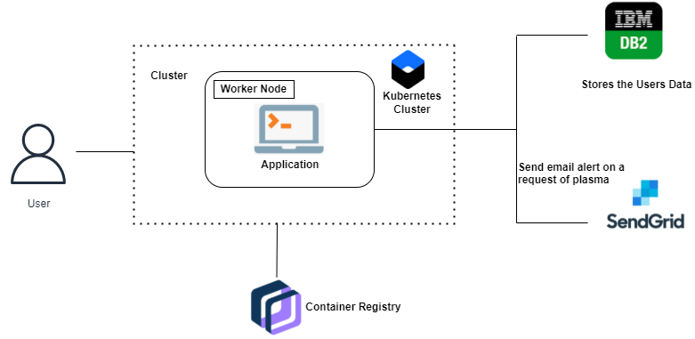

Figure 1: Architecture and data flow of the Plasma Donor Application